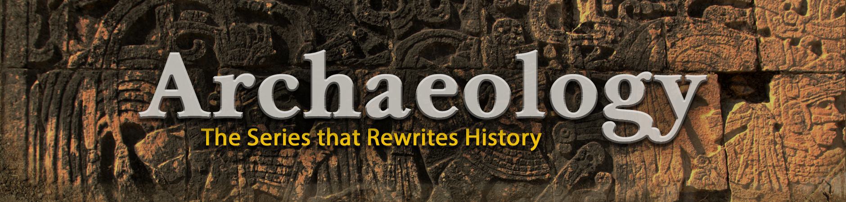

*Archaeology* is an enlightening documentary series that brings the ancient world to life through the lens of modern science and discovery. Across 13 compelling episodes, the series transports viewers to some of the most iconic and remote excavation sites around the globe—revealing the secrets of long-lost civilizations, groundbreaking discoveries, and the enduring mysteries of our human past.

Celebrated for its accessible approach to complex topics, *Archaeology* offers binge-worthy content for fans of history, anthropology, and science-based documentaries. Its broad appeal makes it an ideal addition to educational programming blocks, streaming platforms, or channels focused on history and discovery. From the construction of the pyramids to the decoding of ancient texts, the series uncovers stories buried by time and preserved by science.

More than just a look into the past, *Archaeology* is a tribute to the curiosity, resilience, and innovation of human beings throughout time. With each excavation, it deepens our understanding of where we come from—and what still lies waiting to be uncovered.

**Title:** Archaeology

**Number of Episodes:**  13 episodes x 60 min

**Available Regions:** Worldwide

**Available Languages:** English, Spanish, & French

**Series Premiere:** 1991

**Series Synopsis:** A lost city is discovered in an emerald jungle of Honduras; the

remains of Viking settlements confirm the fierceness of these warriors but also reveal that they were proud poets; recent excavations expose the story of the mass suicide on Masada in ancient Israel as a myth. “Archaeology” brings the diversity of our human past to life with dramatic stories, new discoveries,

and exciting explorations.

**Production Company:** New Dominion Pictures

**Executive Producers:** Nicolas Valcour & Tom Naughton

**Premiere Network:** Discovery Channel

**Original Host:** John Rhys-Davies

**Rating:** TV-PG

**Awards:** 1994 CableACE Winner – Documentary Series

**Contact:** Kristen Eppley – **EVP of International Distribution** [kristen.eppley@newdominion.com](mailto:kristen.eppley@newdominion.com)

Dawn Wilfong – **Creative Director**

[dawn@newdominion.com](mailto:dawn@newdominion.com)

**Social Media Info:** Instagram: [@newdominionpictures](https://www.instagram.com/newdominionpictures/)

Facebook: [@NewDominionPicture](https://www.facebook.com/NewDominionPicture/)

X: [@NewDominionPict](https://x.com/NewDominionPict/)

Hashtags: #TheFBIFiles #FBIFiles

**Assets**

**Logos**



[Color Text](https://newdominion.com/wp-content/uploads/2025/04/Archaeology_Logo_color.png)

[White Text](https://newdominion.com/wp-content/uploads/2025/04/Archaeology_Logo_white.png)

**Artwork**

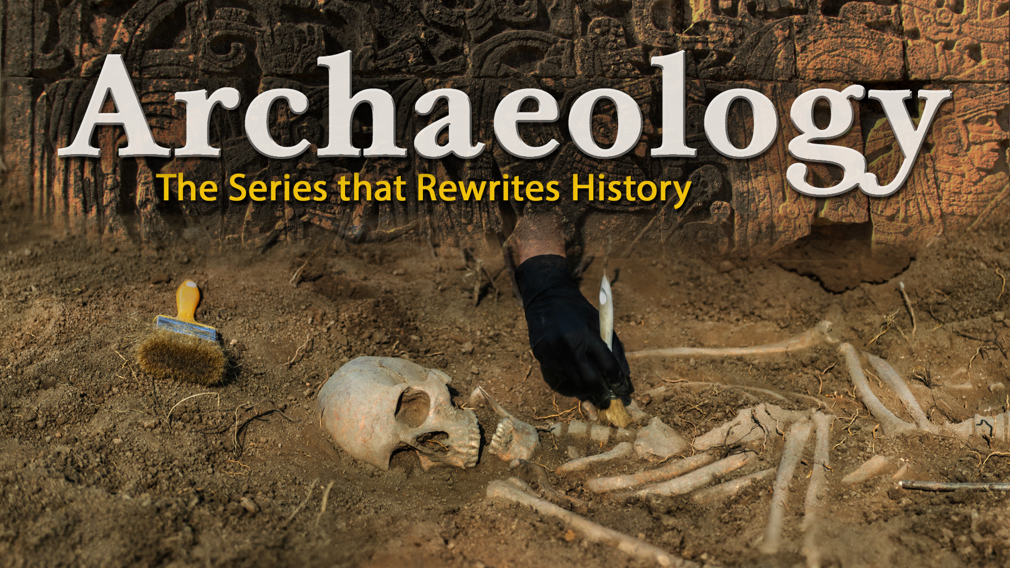

[Poster – 16x9](https://newdominion.com/wp-content/uploads/2025/04/Archaeology_1920x1080.png)

[Poster – 2x3](https://newdominion.com/wp-content/uploads/2025/04/Archaeology_2000x3000-scaled.png)

[Key Art & Stills](https://newdominion.com/wp-content/uploads/2025/04/Archaeology-Key-Art-Posters.zip)